**LAPORAN**

**TUGAS UAS**

**“ ALGORITMA DAN STRUKTUR DATA ”**



**DISUSUN OLEH**

**ACHMAD KELVIN**

**NPM. 4519210089**

**FAKULTAS TEKNIK UNIVERSITAS PANCASILA**

**JURUSAN TEKNIK INFORMATIKA**

**2019 – 2020**

|  |
| --- |
| #include<iostream>  #include<stdlib.h>  using namespace std;  int achcost[10][10],i,j,k,n,madstk[10],keltop,v,vinvisit[10],kelvinvisited[10];  int main() {  int m;  cout << " Masukan vertex = "; cin >> n;  cout << " Masukan Busur = "; cin >> m;  cout << " Busur " <<endl;  for ( k=1; k<=m; k++ )  {  cin >> i >> j;  achcost[i][j] =1;  }  cout << " inisialisasi vertex = "; cin>>v;  cout << " DFS Order Vertex = "; cout << v << " ";  kelvinvisited[v]=1;  k=1;  while (k<n){  for (j=n; j>=1; j--)  if ( achcost[v][j] !=0 && kelvinvisited[j] !=1 && vinvisit[j] !=1)  {  vinvisit[j] =1;  madstk[keltop]=j;  keltop++;  }  v= madstk[--keltop];  cout << v << " ";  k++;  vinvisit[v] =0;  kelvinvisited[v] =1;  }  cin.get();  return 0;  } |

**DEPTH FIRST SEARCH**

**Pseudocode**

Deklrasi variabel

achcost[10][10], i, j, k, n, madstk[10], keltop, v, vinvisit[10], kelvinvisited[10] : int

m : int

deskripsi variabel:

input (n)

input (m)

for (k=1; k<=m; k++)

input( i , j)

achcost[i][j] = 1

endfor

input (v)

print (v, “ “)

kelvinvisited[v] = 1

k = 1

while(k < n)

for (j = n; j >= 1; j--)

if (achcost[v][j] != 0 && kelvinvisited[j] != 1 && vinvisit[j] !=1)

vinvisit[j] = 1

madstk[top] = j

keltop++

endfor

v = madstk[--keltop]

print (v ," ")

k++

vinvisit[v] = 0

kelvinvisited[v] = 1

endwhile

return 0

**Algoritma**

1.Mulai

2. Masukkan data n

3. masukkan data m

4. mencetak variabel (BUSUR)

5. k = 1

6. apabila k <= m) kerjakan

7. masukkan variabel (i,j)

8. achcost [i][j] = 1

9. masukkan variabel V

10. mencetak variabe; (V,' ')

11. kelvinvisited [v]=1

12. selama (k<n)

13. j = n

14 apabila (j >=1)

15. jika (achcost[v][j]!=0 && kelvinvisited [j]!= 1 && vinvisit [j]!=1

16. vinvisit [j] =1

17. madstk [keltop] = j

18. keltop++

19. v = madstk[--keltop]

20. mencetak variabel v

21. k++

22. vinvisit[v] = 0

23.kelvinvisited[v]=1

24. selesai

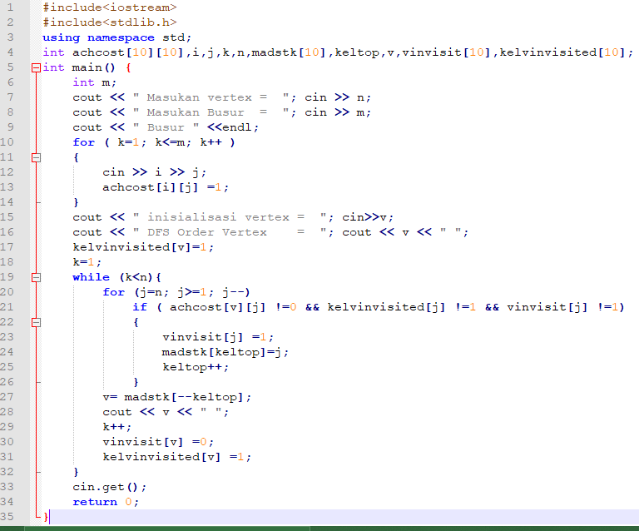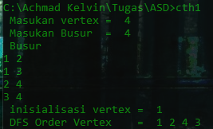**SCREENSHOTS**